Team Members: Brennon Franklin, Danyal Mahmood, Saira Mahmood.

The task presented to the team was to create a game either based around defusing a bomb using strategy or make a twitch game based on finding information and/or images through social media. After deliberating the decision presented the team decided to make the bomb defusal game. The game would consist of six bombs with the layers having to disarm one of them. The bomb they had to defuse was selected through a six-sided die roll.

The rules that were decided upon was that the players would have to roll a six-sided die which would provide them with the bomb they would have to defuse. Only one player would be able to view the bomb they would have to defuse with the remaining players acting as assistants that provide the defuser with instructions on how to defuse the bomb.

The first task that the players had to complete was a wire sequence in which the defuser must cut a wire that changes depending on the number of wires and the colours of the wires present. The wires that must be cut in order to complete the task. The exact instructions were explained in the defusal manual that is provided to the assistants.

The second task that the players had to complete is a minigame in which the players had to spot the of emoji’s and press them in the correct order. All four emoji only appear in one column in the manual and that is where the assistants must find the correct order to guide the defuser. If the defuser presses a single emoji wrong, they will fail the task.

The thirds and final task that players must complete is the maze minigame in which players had to navigate a maze from the starting point which was the blue point found in the map and heading to the red dot by moving one space at a time. The defuser can only see the red dot, the blue dot and two green circles. The green circles were used to determine what maze the assistants must guide the defuser through. Only the assistants were able to see the lines in the maze which meant they had to accurately guide the defuser to save time. As the maze was the last task, they had to complete they could only lose if the remaining time they had left ran out. This meant that they needed to be fast on the other two tasks if they wanted the max amount of time to complete the task.

Some example bombs were created to test the game, however due to time constraints the team was unable to playtest the game. This meant that the team was unaware of any issue’s players may have had when playing the game and that the presentation would be the first time, they received feedback. The feedback from the presentation was to add figure ledgings to our images.

The defusal manual can be found via this link: <https://docs.google.com/document/d/115ORngtn_nnI50ddmiWxTwVCKUzft4sVIfGCOg34C5U/edit?usp=sharing>

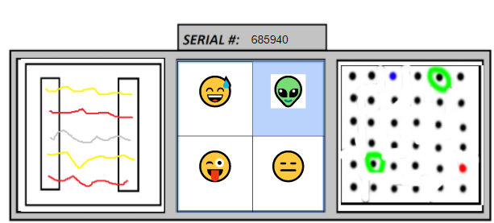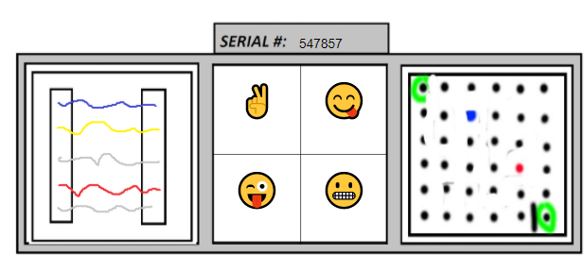

Figure 1. Example bombs.